# PRACTICAL 08

# AIM: Create a Trend Model using data, analyze it and use it for forecasting.

**THEORY**

Forecasting in Tableau uses a technique known as exponential smoothing. Forecast algorithms try to find a regular pattern in measures that can be continued into the future. All forecast algorithms are simple models of a real-world data generating process (DGP). For a high quality forecast, a simple pattern in the DGP must match the pattern described by the model reasonably well. Quality metrics measure how well the model matches the DGP. If the quality is low, the precision measured by the confidence bands is not important because it measures the precision of an inaccurate estimate.

# STEPS

1. Connect to data
   1. In tableau desktop, connect to **superstore sample data** provided by tableau.
2. Create the visualization
3. Create a line chart with ship date (year) in the columns shelf and Sales in the Rows shelf.
4. Go to the analysis tab and click on forecast under model category.
5. On completing the above step, we find the options to set various options for forecast.
6. Choose the forecast length as 2 years and leave the forecast model to automatic and then click ok.
7. We also get minute details of the forecast model by choosing the option describe forecast. To get this option, right-click on forecast diagram.
8. For trend model create a line chart with order date (year) in the columns and sales in the row shelf.
9. After the graph is completed we have to go to analysis tab and click on trend line under model category.
10. After the completion of above step we get a fine dashed line across the data line.
11. We can also get minute details of the trend line model by choosing the describe trend line. To get this option, right-click on the trend line.

**RESULTS**

1. Forecasting

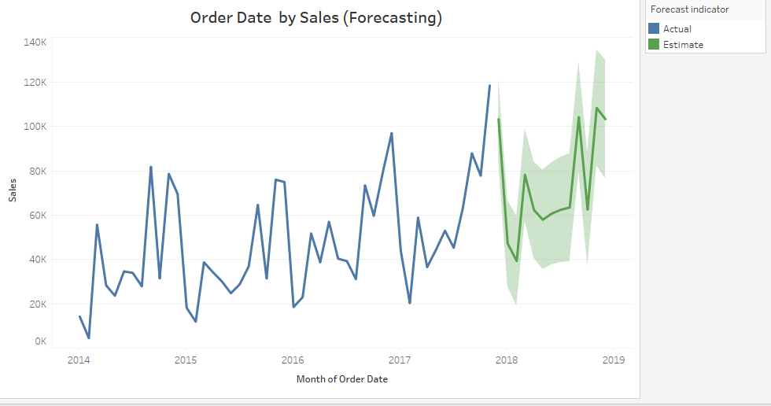

Trend Model Line

